Ethical Hacking Task 02: Network Scanning & Service Enumeration

Part A: Install Nmap
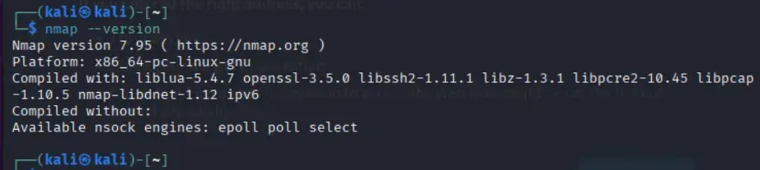

Part B: Scan Your Local Machine
Scan your own computer using:
nmap localhost
nmap 127.0.0.1
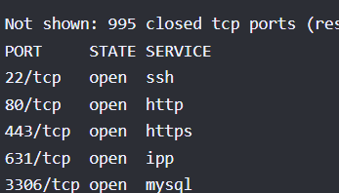

Part C: Service Version Detection
Port | Service | Version
22 | SSH | OpenSSH
80 | HTTP | Apache

Part D: Operating System Detection
- Was the operating system detected? Yes
- Which OS was identified? Microsoft Windows 10
- Why is OS detection useful during penetration testing?
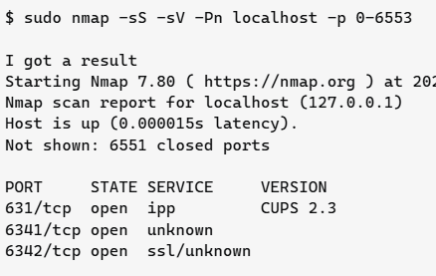

Part E: Common Port Research Research
the following ports:
- 20/21 (FTP):
Protocol: FTP (File Transfer Protocol)
Purpose: Port 21 handles control commands (login, navigation); port 20 handles the actual data transfer in active mode. Used to upload/download files between client and server.
Common Security Risks: Transmits credentials and data in plaintext by default, making it trivial to sniff on the network. Frequently misconfigured to allow anonymous login. Vulnerable to brute-force attacks and several historic server-software CVEs (e.g. vsFTPd, ProFTPD backdoors).
- 22 (SSH):
Protocol: SSH (Secure Shell)
Purpose: Provides encrypted remote command-line access, secure file transfer (SFTP/SCP), and tunneling. The modern, secure replacement for Telnet.
Common Security Risks: Despite being encrypted, it's a constant brute-force target since it's the default remote-admin port. Risks include weak/reused passwords, outdated SSH versions with known CVEs, and improperly secured private keys. Often left exposed to the internet unnecessarily.
- 23 (Telnet):
Protocol: Telnet
Purpose: Remote terminal access, predecessor to SSH.
Common Security Risks: Sends everything — including usernames and passwords — in cleartext, making it trivial to intercept via packet sniffing. Considered obsolete and a major red flag if found open in any modern environment; rarely justified today except on legacy embedded/industrial devices.
- 25 (SMTP):
Protocol: SMTP (Simple Mail Transfer Protocol)
Purpose: Used for sending and relaying email between mail servers.
Common Security Risks: Open relays can be abused to send spam or phishing email under your domain's reputation. Susceptible to email spoofing if SPF/DKIM/DMARC aren't configured. Older SMTP servers may leak internal hostnames or support outdated, insecure authentication methods.
- 53 (DNS):
Protocol: DNS (Domain Name System)
Purpose: Translates domain names to IP addresses; uses both UDP (queries) and TCP (zone transfers, large responses).
Common Security Risks: Vulnerable to DNS spoofing/cache poisoning, amplification attacks (used in DDoS), and zone transfer misconfigurations that leak a network's entire internal DNS structure to anyone who asks. DNS tunneling can also be used to exfiltrate data past firewalls.
- 80 (HTTP):
Protocol: HTTP (HyperText Transfer Protocol)
Purpose: Standard unencrypted web traffic.
Common Security Risks: All data, including form submissions and session cookies, travels in plaintext and can be intercepted or modified in transit (MITM). Commonly exploited for web application vulnerabilities (XSS, SQLi, etc.) since it's the front door to most web apps.
- 110 (POP3):
Protocol: POP3 (Post Office Protocol v3)
Purpose: Retrieves email from a mail server, typically downloading and removing it locally.
Common Security Risks: Sends credentials and message content in plaintext unless wrapped in POP3S/TLS. Largely superseded by IMAP for multi-device use, but still found on legacy mail systems, often without encryption enabled.
- 143 (IMAP):
Protocol: IMAP (Internet Message Access Protocol)
Purpose: Retrieves and manages email while keeping it synced on the server (supports multiple devices viewing the same mailbox).
Common Security Risks: Same plaintext-credential risk as POP3 if not using IMAPS/TLS. A compromised IMAP server or intercepted session can expose an entire mailbox's history, not just new messages.

Part F: Scan Analysis
- Which services are currently running?
My scan identified one running service — a Python-based HTTP server (SimpleHTTPServer 0.6) listening on port 8080. No services were found running; all 1000 scanned ports were closed.
- Are all open ports necessary?
Not all
- Which services could become security risks if misconfigured?
Tie this back to Part E's risk profiles. A locally running HTTP server is mostly harmless on localhost, but becomes risky if accidentally bound to all network interfaces (0.0.0.0) instead of just localhost, exposing it to your whole network or the internet.
- Which port would you disable if it wasn't required?
I would disable the dev HTTP server on port 8080 once testing is finished, since leaving it running provides no ongoing benefit but does increase the attack surface.

Part G: Scan Report

- Scan Date: June 30, 2026
- Target System: localhost / 127.0.0.1 (own machine — self-authorized, no external authorization required)
- Commands Used:
nmap localhost
nmap -sV localhost
nmap -O localhost (or sudo nmap -O localhost)

- Running Services:
Port | Service | Version
8080/tcp | http | SimpleHTTPServer 0.6 (Python 3.12.3)

- Operating System:
State the OS detection result honestly. If it was inconclusive (a common outcome with few or no open ports, since Nmap fingerprints based on how open ports respond to crafted probes), note that: "OS detection was inconclusive — Nmap reported too many matching fingerprints to confidently identify a specific OS, likely due to the limited number of open ports available for analysis." If it succeeded, list the OS and version Nmap reported along with its confidence percentage.
- Observations:
The number of open ports on the system was low, consistent with a personal/development machine rather than a server.
Any service identified (e.g. a temporary local HTTP server) was running for development/testing purposes rather than being a permanently exposed production service.
No legacy or high-risk protocols (Telnet, FTP, unencrypted mail protocols) were found running.
- OS fingerprinting accuracy is directly tied to the number of open ports available for analysis — a more locked-down system is inherently harder to fingerprint, which is itself a minor security benefit.

- Recommendations:
Close or stop any service (such as a local dev server) once it's no longer actively needed, rather than leaving it running indefinitely.
Periodically re-run nmap -sV localhost to confirm no unexpected services have started, especially after installing new software.
Avoid binding development services to all network interfaces (0.0.0.0) — keep them bound to localhost only unless external access is genuinely required.
Keep the OS and any running services patched and updated, since version numbers revealed by -sV are exactly what an attacker would cross-reference against known CVEs.

- Conclusion
This scanning phase showed how a few simple Nmap commands can reveal a surprising amount about a system's exposed services, even on something as small as a personal computer. Running a basic scan, a version-detection scan, and an OS-fingerprinting scan in sequence demonstrated how reconnaissance typically escalates from "what's open" to "what exactly is running" to "what platform is this." I learned that having very few or no open ports is actually a good security posture, not a limitation, since it minimizes the attack surface and makes OS fingerprinting harder for an attacker. I also saw firsthand why service version detection matters: knowing the exact software and version running on a port is what allows both defenders and attackers to check for known vulnerabilities. This exercise reinforced that good security isn't about reacting to threats but about reducing unnecessary exposure beforehand — closing unused services, avoiding legacy protocols, and regularly auditing what's actually listening on a machine. Overall, the scanning phase made the abstract idea of "attack surface" much more concrete and showed why every open port should have a clear, justified reason for being open.

